1. Set proxy

export http_proxy=http://16.85.88.10:8080

export https_proxy=http://16.85.88.10:8080

1. Install java

apt-get update

apt-get install openjdk-8-jdk

1. Install Jenkins

wget -q -O - [http://pkg.jenkins.io/debian/jenkins.io.key](http://pkg.jenkins-ci.org/debian/jenkins.io.key) | sudo apt-key add -

sudo echo deb [http://pkg.jenkins.io/debian binary/](http://pkg.jenkins.io/debian%20binary/) >> /etc/apt/sources.list

sudo apt-get update

sudo apt-get install jenkins

1. Add slave

If you get this error

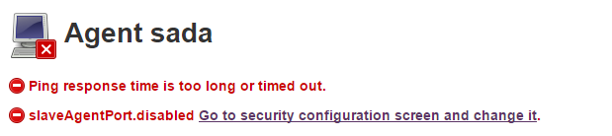

Click



Select



on

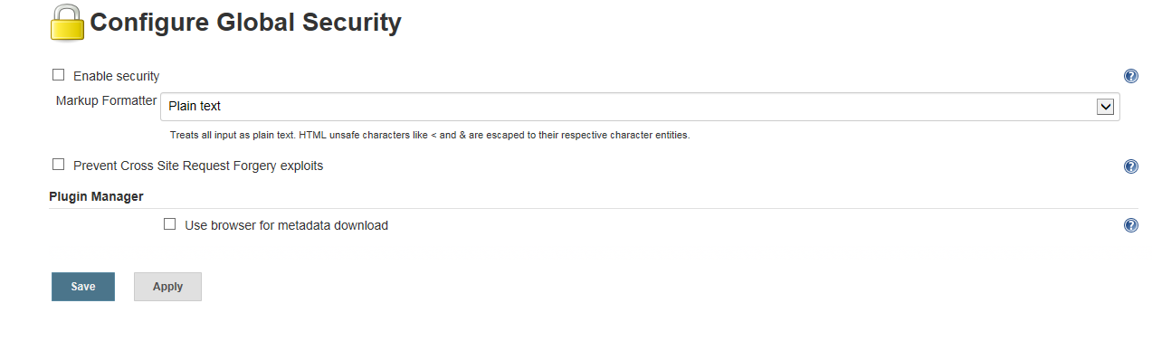



Choose Rondom

Then you will get

